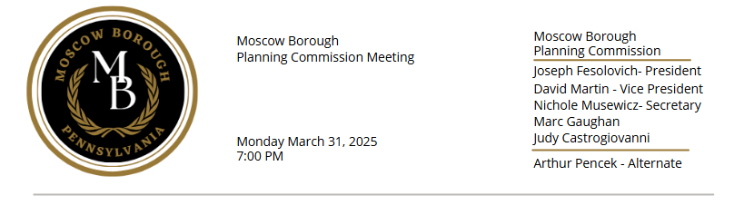

*\*Please note Council meetings are recorded and are transcribed at a later date*

1. **CALL TO ORDER** Joseph Fesolovich, Planning Commission Chair
2. **ROLL CALL**

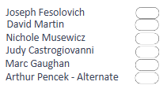

1. **APPROVAL OF MINUTES**
2. Approval of Moscow Borough Regular Monthly Planning Commission Meeting Minutes   
   from November 25, 2024 (copy provided)
3. **GEORGE PARKER, ZONING AND CODE ENFORCEMENT OFFICER**
4. Zoning Reports from December 2024, January 2025, February 2025 and March 2025 (copies provided)
5. Update of complaint of raw garbage waste outside at 1302 Church Street
6. JUSTIN AND ANGELA PADAVANO – 201 MAIN STREET, MOSCOW PA
7. Letter dated March 18, 2025 regarding proposed Development of Commercial Use of   
   Property (copy provided)
8. **ST. MARK’S EPISCOPAL CHURCH - 1109 CHURCH ST, MOSCOW, PA**
9. Rebecca McGlaughlin in attendance to make a presentation regarding use of the Episcopal   
   church rooms for pre-school classes by a private company
10. **REGIONAL PLANNING (Mary Liz Donato, Moscow Borough Planning Consultant)**
11. **MOSCOW SEWER AUTHORITY**
12. **OLD BUSINESS**
13. **NEW BUSINESS**
14. Marc Gaughan would like to discuss Property Maintenance Codes
15. **ADJOURNMENT**